When some users use the ESC without BEC, the receiver data will be disordered, especially in the case of pushing the throttle; the phenomenon is that the throttle is unstable, the mode is chaotic, and the throttle is pushed into the OSD setting screen. If there is no such problem, there is no need to change it.

The reason for this is that there is generally no filter capacitor through the electromechanical adjustment; the interference caused by the motor in the start or the large throttle is transmitted to the flight controller; for this we propose two simple schemes:

**Solution 1: Two 220uF/470uF electrolytic capacitors are connected in parallel with the input terminal of the ESC. To use the capacitor with high frequency and low internal resistance, pay attention to the withstand voltage of at least 1.5 times the input voltage. Note that the capacitor should be as close as possible to the input end.**

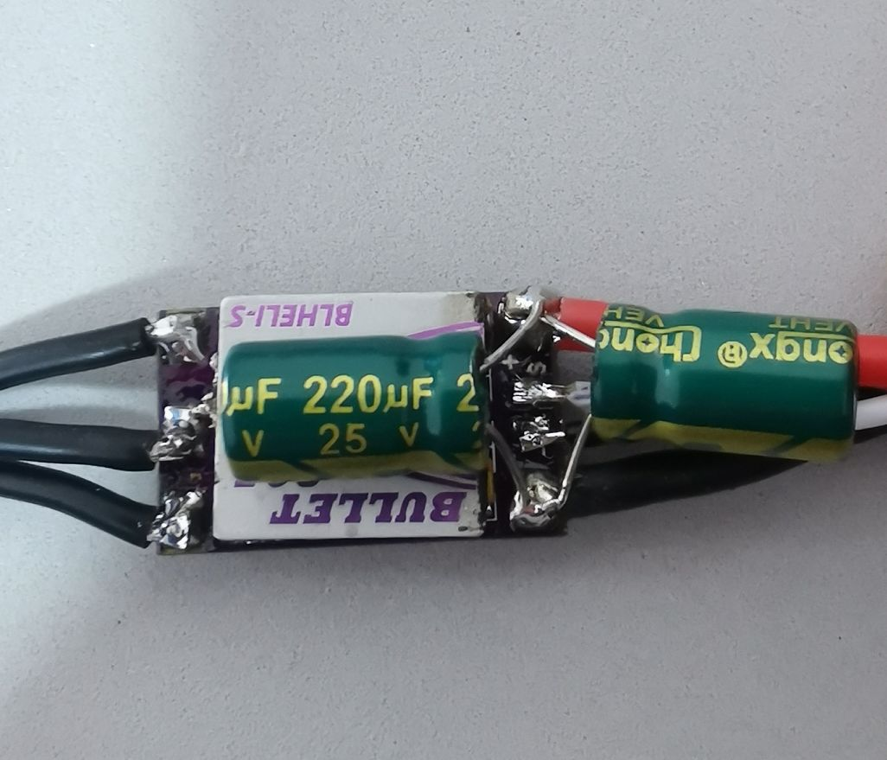

**Solution 2: On the back of the flight controler, the red bead magnet device (black-like resistor-like device) is removed with a soldering iron. When removed, two small pads are exposed, and the wires are shorted by two small pads. .**

**The shielding of the action of the magnetic beads absorbs the interference, but the interference when the ESC is activated and the magnetic beads play a role, and the above problemcan also be solved after the short circuit.**  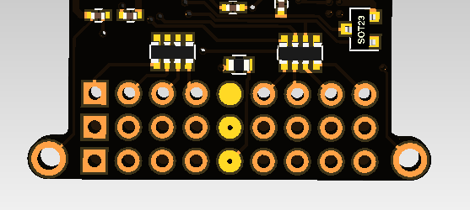

Short wire like this

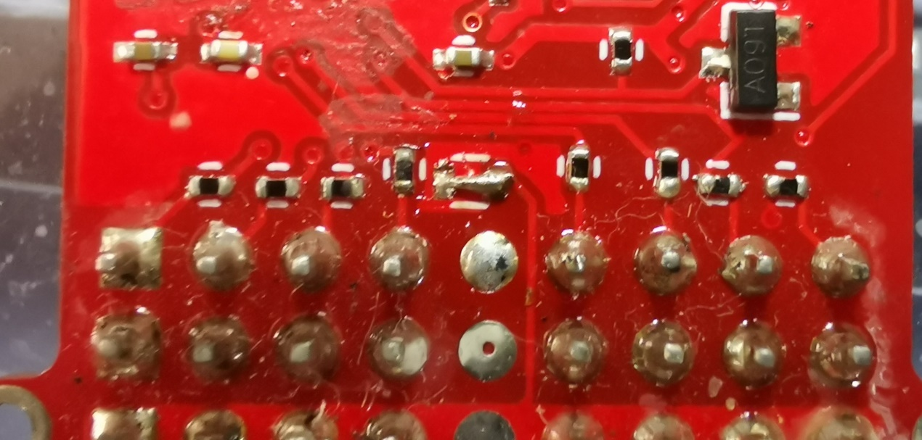

LeFeiRC

2019/4/12